1.Create a shell script to print the HTTP error code of guvi.in & print, the success/failure message based on the error code response

**Solution:-**

Wrote a script(file name🡪task.sh)

Where curl 🡪 look the content of the webpage.

-I 🡪 This option tells curl to perform a HEAD request instead of a GET request. It retrieves the headers of the specified URL without downloading the content.

-s 🡪 This option stands for "silent" mode. It suppresses the progress meter and other non-error informational messages.

-L🡪 This option instructs curl to follow redirects. If the requested URL redirects to another location, curl will follow the redirect and retrieve the final destination.

grep 🡪 This command is used to search for a particular text, here it is searching for HTTP

tail -n 🡪 This cmd is used to display the last part of the file along with number of lines need to be displayed.

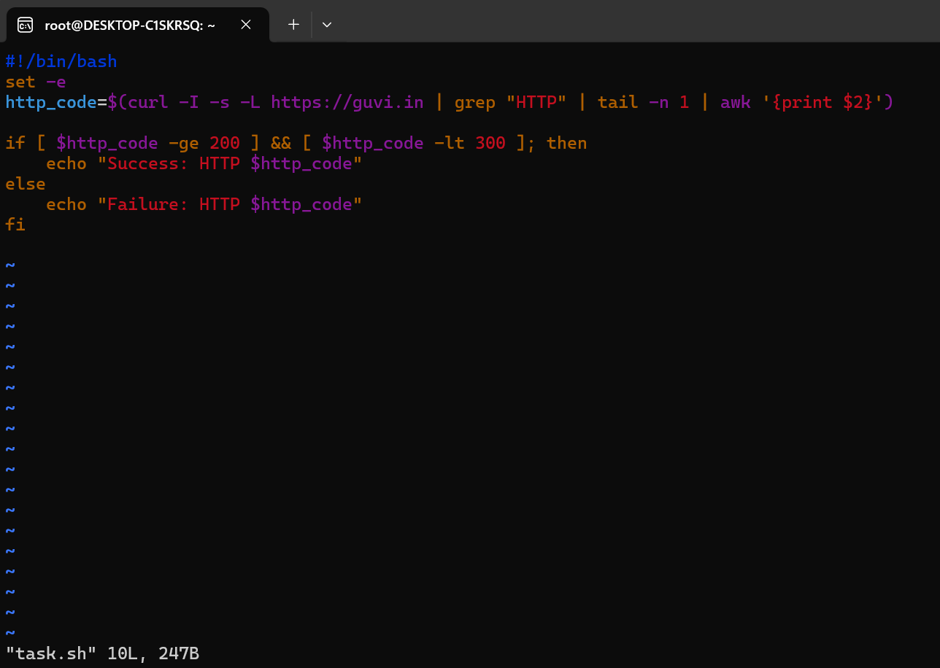

Provided permission to the script and executed it.

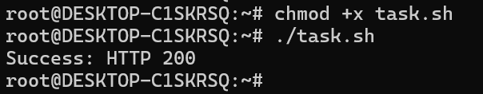

2.Given a file, replace all occurrence of the word ""give"" with ""learning"" from the 5th line till the end in only those lines that contain the word "welcome"

**Solution:-**

Below script is file1.txt, it holds the below details.

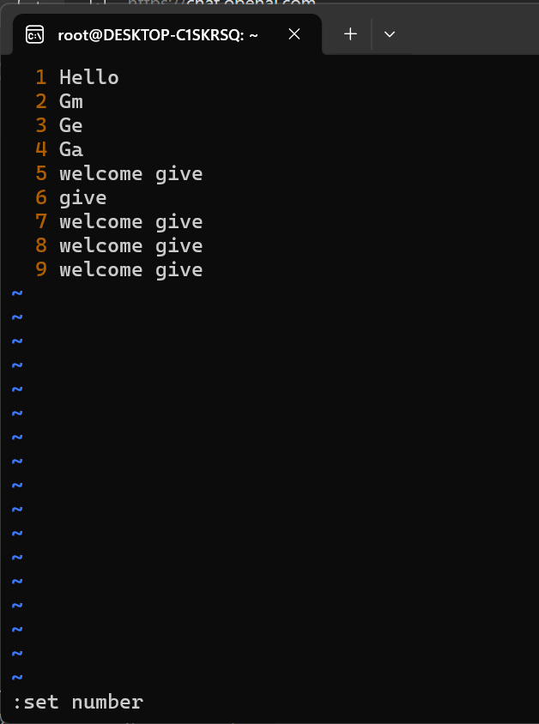

Again wrote one more script(task1.sh) with sed command

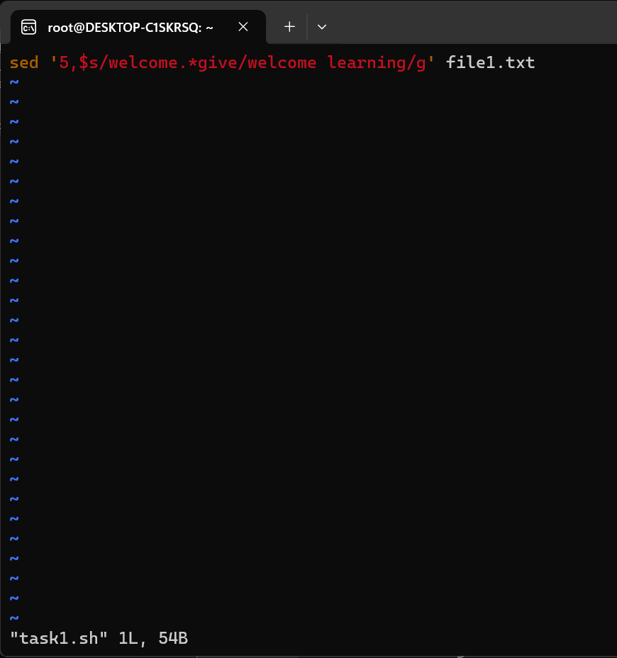

Where,

5,$ --> This specifies that the replace should occur from the 5th line (5) till the end of the file ($).

s/welcome.*give/welcome learning/g: This is the substitution command (s). It looks for lines containing "welcome" followed by anything (.*) and "give". It replaces "give" with "learning" in those lines

Below the task1.sh has been given with execute permission and ran the script.

